Book Review: Graphic Classics Volume Three: H.G. Wells, by H.G. Wells, ed. by Tom Pomplun, introduced by Ray Vukcevich, illustrated by Dan O’Neill, Skip Williamson, Alex Niño, Shary Flenniken, Nicola Cuti, Shag, M.K. Brown, Brad Teare, John Pierard, Milton Knight, Antonella Caputo, Nick Miller, Chris Moore, Rick Geary, Kent Steine, Henry Ng, Vincent Di Fate, Jim Nelson and H.G. Wells (Mount Horeb, WI: Eureka Productions, 2002). 144 pp. ISBN 0-9712464-3-2 (pb) US$9.95. [By John S. Partington]

In the letter accompanying the review-copy of Graphic Classics Volume Three: H.G. Wells, Tom Pomplun, the designer and publisher of the volume, writes, ‘This is the third in a series of books which presents classic literature in comics and heavily-illustrated for adult readers. Each volume will focus on one writer, with illustration by some of the top artists working today in comics, book illustration and fine arts.’ The other authors published in the series are Edgar Allen Poe and Arthur Conan Doyle, with H.P. Lovecraft and Jack London to follow shortly.
The volume under review contains interpretations of eleven of Wells’s best stories, and an additional story portraying the events surrounding Orson Welles’s 1938 War of the Worlds broadcast, all in comic-strip format. The stories used in the book are as follows: ‘The Invisible Man’ (abridged), ‘The Man Who Could Work Miracles’ (adapted), ‘A Moonlight Fable’, ‘The Man with a Nose’, ‘In the Abyss’ (adapted), ‘The Truth about Pyecraft’ (edited), excerpts from ‘The Time Machine’, ‘The Temptation of Harringay’, an excerpt from ‘The Desert Daisy’, ‘Le Marie Terrible’ and ‘The Star’. The illustrations, being by divers hands, cover several different styles and periods, from Wells’s own juvenile drawings for ‘The Desert Daisy’ and the art nouveau of Shag’s ‘Le Marie Terrible’, to the DC-Comic-style sketches of ‘The War of the Worlds’. As several of the stories are edited, adapted or excerpted (while ‘The Star’ contains no text at all), this book is not for those interested merely in reading Wells’s stories. Rather, the book is a pictorial feast of interpretation. It demonstrates just how inspirational Wells’s literature remains, providing the subject matter for comics that, far from appearing as retrospectives to an author of the past, are as fresh as any original piece of comic-book storytelling. The volume demonstrates, if anyone requires such a demonstration, Wells’s timelessness and contemporaneity some 56 years after his death. The fact that his writings of the late-
nineteenth and early-twentieth centuries continue to inspire comic-book illustrators, as well as filmmakers, writers, scientists and journalists, at the beginning of the 21st century is a tribute to his craft as an imaginative artist.
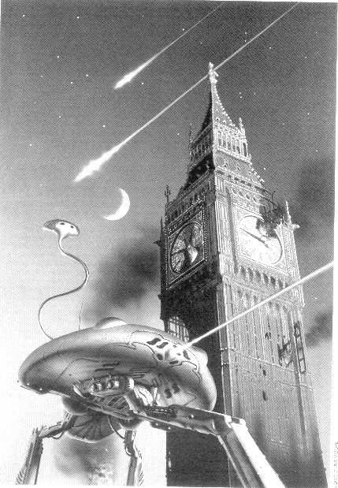
The book is introduced by Ray Vukcevich, author of The Man of Maybe Half-a-Dozen Faces (St Martin’s Press, 2000) and Meet Me in the Moon Room (Small Beer Press, 2001), who reminisces about how he became interested in science fiction, learning of Wells through comic books of the 1950s before discovering the actual bound volumes some years later. The only other text (apart from the stories themselves) is an introduction to ‘The Desert Daisy’ (anonymous, but presumably penned by Tom Pomplun) in which it is stated ‘H.G. Wells, comic book artist? Among his many other accomplishments, Wells might be

credited as one of the earliest practitioners of the form in his illustrated book The Desert Daisy’ (1879). About that story the introduction presciently comments, ‘While it is clearly a child’s fairy tale, The Desert Daisy shows the roots of Wells’ interest in war and the

follies of politics, society, and religion which are explored in greater depth throughout his career.’
To many this volume will be simply a curiosity. However, for those who met Wells through science-fiction magazines, this reinterpretation will be a pleasing addition to their bookshelves. It is also a superb introduction to young people of the magic of Wells’s stories. A third target group for this edition is graphic artists; there is much contained within this volume to inspire new illustrated editions of Wells’s work.
Those interested in acquiring a copy of this book (or any in the series) should either visit the ‘Graphic Classics’ website <www.graphicclassics.com> or contact Eureka Productions by email <eureka@chorus.net>, telephone (US 608-832-6448), fax (US 608-832-6449) or in writing (Eureka Productions, 8778 Oak Grove Road, Mount Horeb, WI, USA 53572).
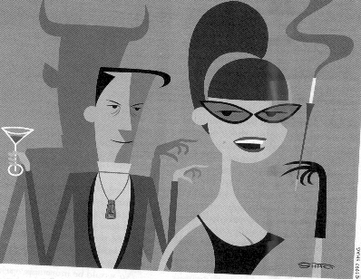
[Above, an illustration for ‘The War of the Worlds’ by Chris Moore, and below, an illustration for ‘Le Marie Terrible’ by Shag.]

